PLANT GROWTH AND GAS EXCHANGE

HIGH SCHOOL STUDENT ACTIVITY PAGES

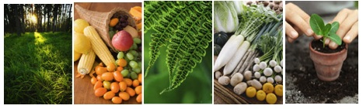

Culturally relevant ecology, learning progressions and environmental literacy

Environmental Literacy Project
http://edr1.educ.msu.edu/EnvironmentalLit/index.htm

Eric Keeling, Dijanna Figueroa, Jonathon Schramm, Lindsey Mohan, and Charles W. Anderson
With help from Cheryl Hach, Becky Drayton, Dante Cisterna, and Lori Spindler
October, 2010

Development of these materials is supported by a grant from the National Science Foundation: Targeted Partnership: Culturally relevant ecology, learning progressions and environmental literacy (NSF-0832173), with additional support from Developing a Research-based Learning Progression for the Role of Carbon in Environmental Systems (REC 0529636), Learning Progression on Carbon-Transforming Processes in Socio-Ecological Systems (NSF 0815993), and the Great Lakes Bioenergy Research Center. Any opinions, findings, and conclusions or recommendations expressed in this material are those of the author(s) and do not necessarily reflect the views of the National Science Foundation or the Department of Energy.
Contents
Activity 1: How Do Plants Grow? 3
Activity 2: Zooming In and Out 6
Activity 4: Molecules Quiz 8
Activity 5: Investigating Weight Gain and Weight Loss 9
Activity 6: Does CO₂ Have Mass? 14
Activity 7: Gas Exchange in Plants 16
Activity 8: Photosynthesis and Respiration 17
Activity 9: Harvesting Plants 19
Activity 10: Gaining, Transforming and Losing Plant Mass 20
Activity 11: What’s the “Matter” with Carbon? 22

Name: _________________________ Period: _____ Date: ______________

Activity 1: How Do Plants Grow?

Large plants can grow from small seeds into large trees. What do you think a plant needs to grow?

What evidence can you use from your own previous experiences that plants need these things?

How do you think that plants use the things they need in order to grow?

Today you will set up an experiment to test some of your ideas about what plants need to grow. Your group will grow plants from seeds and measure their growth. You will set up the experiment today and monitor the growth of your seeds over the next two to three weeks.

** KEEP THIS HANDOUT TO RECORD YOUR DATA! **

We will be setting up two types of plants to grow.

One: We will grow radishes in soil
Two: We will grow beans in soil

Methods
Radishes
- Make a 1-cm long cut in the bottom of your dish, then feed a small piece of the wicking cloth through the cut, with about half the length in and half out of the dish.
- Label your dish with your group name and/or class period.
- Weigh your empty cup and record its mass below.
- Fill the cup ¾ full with vermiculite (if not already done by your teacher).
- Use the table below to record the following measurements for the radish seeds:

Radish seeds: Cup number ________

Mass of empty cup: | Mass of cup filled with vermiculite: | Mass of just the vermiculite: | Number of radish seeds:
Mass of radish seeds: | Mass of cup with vermiculite and seeds:
Your prediction: What will happen to the mass when the plants grow? |  | Reason for your prediction:

Plant your seeds in the soil – do not put all the seeds in the same spot.
- Water the growing containers carefully.
- Place your growing containers in the light near a window if possible.

Beans

- Follow the same steps for bean seeds as for radish seeds. Use the table below to record data about your bean seeds

Bean seeds: Cup number ________

Mass of empty cup: | Mass of cup filled with vermiculite: | Mass of just the vermiculite: | Number of bean seeds:
Mass of bean seeds: | Mass of cup with vermiculite and seeds:
Your prediction: What will happen to the mass when the plants grow? |  | Reason for your prediction:

- Water the seeds as you did for the radish and place the cup in the growing area.

You will need to monitor your plants to track their progress and add water as necessary. You should check your plants every day and fill out the data table on the following page about every 2 days. You should note the general health and growth patterns of the plants: Have all survived? Are all producing healthy green leaves? and so forth. Make sure that you write complete and accurate descriptions of your plants.

Date
Radish: number of shoots

Radish Observations

Bean: number of shoots

Bean Observations

Additional Observations:

Do your observations confirm what you thought a plant needed to grow? Why or why not?

Name: _________________________ Period: _____ Date: ______________

Activity 2: Zooming In and Out

When thinking about different scales, we can generally group systems and parts of systems into one of four groups: 1) atomic-molecular (things we cannot see even with a microscope), 2) microscopic/cellular (we cannot see with our eyes, but can use a microscope to see), 3) macroscopic (things we can see with our eyes), and 4) large scale (things that are too large to see with our eyes as a whole).

The following is a list of systems included in the Powers of Ten video. Try to sort these systems into one of the four categories described above.

Universe Man or Woman Cell Nucleus United States
Hand Earth Lake Michigan DNA molecule
Skin Carbon Atom Picnic Blanket Galaxy
Capillaries Skin Cell Quarks Chicago
City Park White Blood Cell Solar System

- What systems would you see at the atomic/molecular level?

- What systems would you see at the microscopic or cellular level?

- What systems would you see at the macroscopic level?

- What systems would you see at the large-scale level?

- Are there any systems that you are unsure about?

You may watch the Powers of Ten video again. However, this time your teacher will pause the video at each scale, and you will need to think about what appears and disappears when you zoom in or out. You will need to complete the table below, and as you watch the video again, think about the size of different systems and if they match the groups you made on the first page.

What You See When You Zoom In | Starting Point:  What You See | What You See When You Zoom Out
 | City Park
 | Chicago
 | United States
 | Solar System
 | Galaxy
 | Hand
 | Skin
 | Capillaries
 | DNA molecule
 | Carbon Atom

After watching the video again, is there anything you would change from your groups on the first page?

Name: _________________________ Period: _____ Date: ______________

Activity 4: Molecules Quiz

1. Fill in the table below about the kinds of atoms and molecules in air, plants, and soil.
Material | What kinds of atoms are in this material? | What kinds of molecules or ions are in this material? | Do these molecules have stored chemical energy (in C-C or C-H bonds?
Air

Plants

Soil (include only water and minerals that plants can absorb through their roots)

2. What are your thoughts about the question at the end of the reading: Where do the molecules in plants come from?

Name: __________________________________Period: ______ Date: ____________

Activity 5: Investigating Weight Gain and Weight Loss

First Questions about Gaining and Losing Weight
We all know that people can eat food and gain weight, and that plants can grow and gain weight. But what does it REALLY mean to gain weight? Try filling out the table below.
When you add water to a sponge, does it gain weight? | Yes  No | Explain your answer
When you drink a cup of water, do you gain weight? | Yes  No | Explain your answer
When a plant grows in the sunlight, does it gain weight? | Yes  No | Explain your answer
What measurements do you need to make to determine if a plant has gained weight?

Does water make a sponge gain weight

Materials:
1 plastic cup
1 dry sponge
Tap or distilled water
1 small digital balance (300-g capacity)

What to do:
This will be a two-day experiment:
- On the first day, you will predict and measure the mass of the sponge before and after you add water. This means you will:
  - Weigh the dry sponge
  - Weigh a cup, then add some water and weigh the cup filled with water.
  - Figure out the weight of just the water. How can you do that?
  - Predict the weight of moist sponge after it soaks up the water.
  - Weigh the moist sponge to see how well you predicted.
- Your teacher will dry the sponge out overnight
- On the second day, you will predict and measure the mass of the dried sponge.
You can use the table below to record your predictions and measurements.

Day 1: Weighing Wet and Dry Sponge
Mass of dry sponge: | Mass of empty water cup: | Mass of cup with water added: | Mass of just the water:
Your prediction: What will the mass be when the water is added to the sponge? | Reason for your prediction: |  | Actual measurement: What mass did you measure?
Day 2: Weighing Sponge that Has Been Dried Overnight
Your prediction: What will the mass be when the sponge is dried overnight? | Reason for your prediction: |  | Actual measurement: What mass did you measure?

When we added water, did the sponge did gain weight? Explain your reasoning?

Use the mass tracing process tools to trace the masses for the wet and dry sponge.
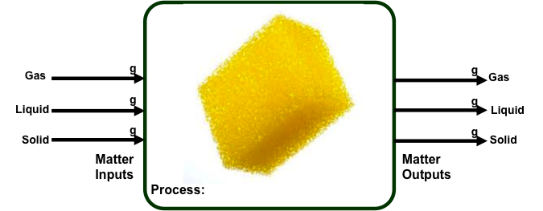
Wetting sponge: Fill in the masses that you measured. Is mass conserved?
Drying sponge: Fill in the masses that you measured. What happened to the mass of the water?

Does water make vermiculite gain weight

Materials:
1 tin or plastic cup
Enough vermiculite to fill cup halfway
Tap or distilled water
1 small digital balance (300-g capacity)
100-mL beaker or graduated cylinder

What to do:
This will be a two-day experiment:
- On the first day, you will predict and measure the mass of vermiculite before and after you add water. This means you will:
  - Put some vermiculite in a small cup and weigh it.
  - Weigh another cup, then add some water and weigh the cup filled with water.
  - Figure out the weight of just the water. How can you do that?
  - Predict the weight of the cup of vermiculite after the water is added.
  - Weigh the cup to see how well you predicted.
- Your teacher will dry the vermiculite out overnight
- On the second day, you will predict and measure the mass of the dried vermiculite.
You can use the table below record your predictions and measurements.
Day 1: Weighing Wet and Dry Vermiculite
Mass of cup filled with vermiculite: | Mass of empty water cup: | Mass of cup with water added: | Mass of just the water:
Your prediction: What will the mass be when the water is added to the cup of vermiculite? | Reason for your prediction: |  | Actual measurement: What mass did you measure?
Day 2: Weighing Vermiculite that Has Been Dried Overnight
Your prediction: What will the mass be when the cup of vermiculite is dried overnight? | Reason for your prediction: |  | Actual measurement: What mass did you measure?

When you added water, did the vermiculite did gain weight? Explain your reasoning?

Use the mass tracing process tools to trace the masses for the wet and dry vermiculite.
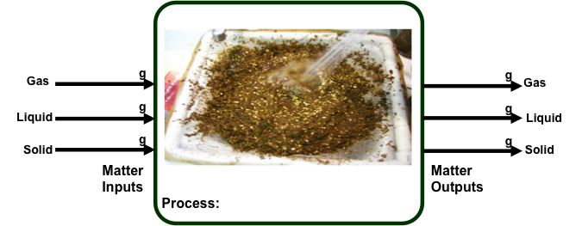
Wetting vermiculite: Fill in the masses that you measured. Is mass conserved?
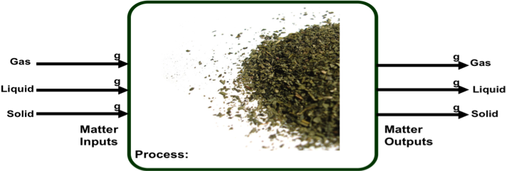
Drying vermiculite: Fill in the masses that you measured. What happened to the mass of the water?

Does water make people grow?
Materials
Bathroom scale
Scale for weighing large glass or bottle of water
Glass or bottle
Water

What to do:
Now try an experiment with a member of your class who volunteers:
- Weigh your classmate on the bathroom scale.
- Weigh the bottle or glass, then add some water and weigh the bottle filled with water.
- Figure out the weight of just the water. How can you do that?
- Predict the weight of your classmate after s/he drinks the water.
- Weigh your classmate to see how well you predicted.

You can use the table below to record your predictions and measurements.
Mass of your classmate: | Mass of empty water bottle: | Mass of bottle with water added: | Mass of just the water:
Your prediction: What will your classmate’s mass be after s/he drinks the water? | Reason for your prediction: |  | Actual measurement: What mass did you measure?

1. What do you think might happen to the mass of your classmate overnight? Why?

2. Do you think your classmate REALLY gained weight after drinking the water? Explain your reasoning.

Do Plants Gain Mass When You Water Them?
Materials
1 small digital balance (300-g capacity)
Plant that you are growing
Small plastic cup
Water

What to do:
- Weigh your plant in its cup on the digital balance.
- Weigh the cup, then add some water and weigh the cup with water.
- Figure out the weight of just the water. How can you do that?
- Predict the weight of your plant after you have watered it.
- Weigh your plant to see how well you predicted.
You can use the table below to record your predictions and measurements
Mass of your plant in its cup: | Mass of empty water cup: | Mass of cup with water added: | Mass of just the water:
Your prediction: What will your plant weigh after it is watered? | Reason for your prediction: |  | Actual measurement: What mass did you measure?

1. What do you think might happen to the mass of your plant in its cup overnight? Why?

2. Do you think your plant REALLY gained weight when you watered it? Explain your reasoning.

Name: __________________________________Period: ______ Date: ____________

Activity 6: Does CO₂ Have Mass?
Do gases (like air, oxygen or carbon dioxide) weigh anything? In this activity, we will investigate whether the bubbles in a bottle of soda have weight (mass). We will weigh a cup filled with soda immediately after pouring. After some time has passed and bubbles have escaped out of the cup, we will weigh the cup again, still with the soda but without the bubbles.

Before weighing the soda, answer the following questions.
.
Do you thing the air around you weighs anything? | Yes  No | Explain your answer
After we pour the soda and let gas escape will the weight of the cup + soda increase, decrease or stay the same? | Explain your answer

Does the gas in soda have mass?
Materials:
Approx. 50 ml of carbonated soda beverage
Small cup
200-g scale

What to do:
- Your teacher will pour about 50mL of the soda into your cup.
- Read the mass on the scale immediately after the soda is poured, and record it in the table below.
- Record the mass of the cup and soda at two other times during the class period and once at the very end.

Fill in the table below over the rest of the period:

Time | Minutes since start | Weight of soda + cup | Weight of gas lost since start
At Pouring | 0 |  | Weight of gas lost since start
After pouring

The next three experiments will be done as classroom demonstrations.

As your teacher prepares each of the three demonstrations:
- Observe the concentration of CO₂ in the chamber and the mass before the demo. Record your observations in the table below in the appropriate column.
- Observe what happens to the levels of CO₂ and mass, and record a final concentration and mass.
- Please give a brief explanation for why you think this change occurred.

 | Concentration of CO₂ before activity | Concentration of CO₂ after activity | Mass before the activity | Mass after the activity
Candle Burning
Baking Powder + Water
Exhalation

Use the mass tracing process tools to trace the masses for the candle and baking powder in water.
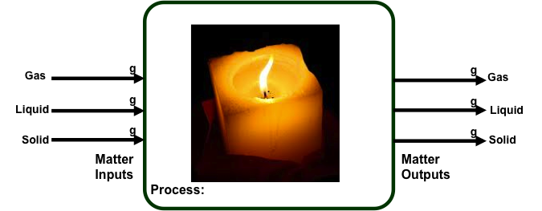
Candle burning. What happened to the mass of the candle when it burned?

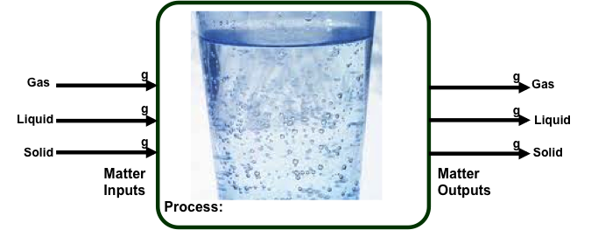
Baking powder in water: What happened to the mass of the baking powder and water mixture when it fizzed?

One last question: What do you think happens to your mass when you breathe out carbon dioxide?

Name: __________________________________Period: ______ Date: ____________

Activity 7: Gas Exchange in Plants
In this activity, we will use probes to study how plants affect levels of CO₂ in the air around them. We will test the plants under two different conditions: 1) When the plant is in the dark, and 2) when the plant is in the light.
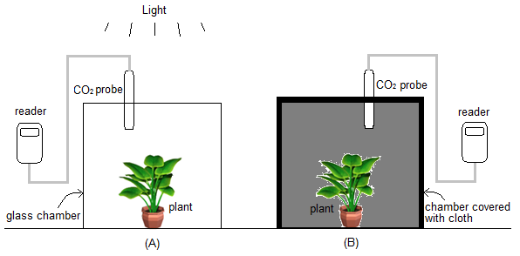
What do you predict will happen to the concentration of CO₂ in each chamber?
 | In the light | In the dark
The amount of CO₂ will… | ◻ increase  ◻ be the same  ◻ decrease | ◻ increase  ◻ be the same  ◻ decrease

Record Data in the table below:
 | In the light |  | In the dark
Time (seconds) | Level of CO₂ in the chamber | Time (seconds) | Level of CO₂ in the chamber
Name: __________________________________Period: ______ Date: ____________

Activity 8: Photosynthesis and Respiration

In the last activity you observed plants living in the light and the dark, and recorded the changes in concentration of carbon dioxide gas in the air around the plants over time. Just to refresh everyone’s memory, what happened to carbon dioxide levels near the plant in the dark? What biological process was mainly responsible for that change?

How about CO₂ levels near the plant in the light? What process was responsible for the change in CO₂ concentrations in this case?

Now let’s consider those processes a little more fully. Working with your lab group, fill in the following process tools for photosynthesis and respiration as completely as you can. They will be more complicated than any of the others that you have completed so far, so check that you include all the inputs and outputs of both matter and energy.
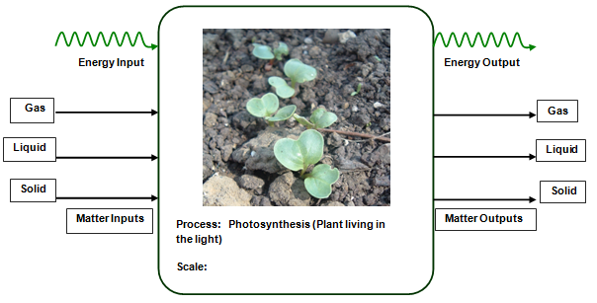
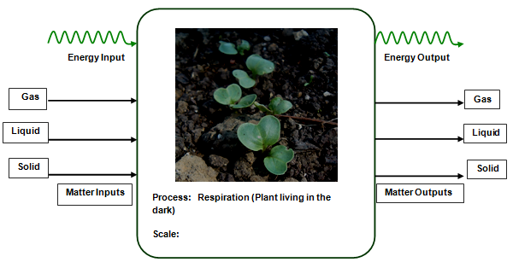

In the next activity you will measure the changes in biomass (the dry mass of the plants that is not water) in the radish plants that you have been growing. What do you predict that you will find?

How do you think that this is happening? How did the plants change their mass?

Name: __________________________________Period: ______ Date: ____________

Activity 9: Harvesting Plants
Within the last week or two, you set up an experiment to observe plant growth. Meanwhile, you have learned about the requirements plants have for growth and the role of gases, particularly carbon dioxide, in that growth. You’ve also discussed the differences between wet and dry weight.
Now you will harvest your radish plants and measure dry weight to see how things have changed.
- Either follow your teacher’s instructions as to how to prepare the samples for drying, or, if this step has already been completed, take out the bag with your dried samples.
- Gently take out the tin cup from your bag, set it aside, and pour the remaining contents of your bag into the weighing boat provided (first note the mass of the empty weighing boat). Check that no soil material is stuck to the inside of your tin cup.
- Using your fingers or tweezers, gently pick out all of the plant material (roots, shoots, potentially even seeds) from the boat and set them in the cup. Now weigh both the boat/soil system and the cup/plant system separately. Subtracting the known masses of the weighing boat and cup, you should be able to calculate the dry mass of both the soil and your radishes. Enter those numbers in Table 1.
Table 1: Dry masses of soil and plants
Total mass of container and contents | Mass of container | Dry mass of contents
Boat + Soil: | Weighing boat: | Soil:
Cup + Plants: | Tin cup: | Plants:

Summary questions
1. What are the materials that contribute to plant mass?

2. What is the meaning of “dry weight”? How is it related to plant growth?

3. Is a plant’s source of energy related to its dry weight? Why?

4. Summarize the process observed during the experiment, from seed germination to the harvest. Include the factors that affect plant growth.

Discussion
Write the main ideas you can conclude from this activity. Remember the purpose of growing the plants was to examine the requirements of plants for growth.
Name: __________________________________Period: ______ Date: ____________

Activity 10: Gaining, Transforming and Losing Plant Mass

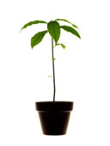
Look at this young tree planted in a bucket of soil. As the tree grows it gains weight. Think about whether the soil is food for the plant.
- Do you think the weight of this tree came mostly from materials the plant took from the soil?
YES NO
- Write down in the box whether you think the weight of the soil in the pot will “increase”, “decrease”, or stay the “same” as the plant grows:
WEIGHT CHANGE OF SOIL

***Read the first part of this lesson’s reading, von Helmont’s Willow Tree, before proceeding.***
- Write down the changes in weight of the tree and the soil.
WEIGHT CHANGE OF TREE | WEIGHT CHANGE OF SOIL
- How would you explain the results that von Helmont found? Where does the majority of a plant’s mass come from if not the soil?

- Why did the soil lose some mass? What components of the soil might now be somewhere else?

Although von Helmont was able to show that plants didn’t simply take mass from the soil for all of their growth, he believed that instead the plant’s material was somehow composed of water, the only thing that he had added to the bucket other than soil. Why is that idea incomplete? What process describing plant growth was unknown to him and other scientists of the time that we now take for granted?

What is the main product of this process that contributes to plant mass?

As you consider any plant, though, it is obvious that although it has both water and this product, it is more complex than either of those things. Can you think of any other molecules that make up a plant’s dry material, and where within the plant or its cells those molecules might be found? (for hints, look back over your reading from activity 4)
***Return to the reading to complete the section Plants: Even more complex than von Helmont knew!***

To summarize all that we’ve discussed, please complete the following table:
 | Gaining Mass | Transforming Mass | Losing Mass
Which process is responsible?
What is the effect on CO₂ around the plant?
What is the main product(s) of the process?

Name: _______________________________Period: ______ Date: __________

Activity 11: What’s the “Matter” with Carbon?

1. What do you know about carbon?

Pick two of these questions and respond to them using your previous ideas about carbon

What is carbon?
Why do we think carbon is so important?
Why do scientists and environmentalists talk about carbon?
What is the meaning of a “carbon footprint”?
What is the big deal about carbon?
What’s the “matter” with Carbon?

- Using the carbon cycle diagram your teacher projected, describe two possible routes of at least three links each that a carbon atom could take through the ecosystem:

1st Location  Component 1 | Process | 2nd Location | Process | 3rd Location

